
AquaLoops4Med

AquaLoops4Med Open call
Consortium Declaration of Honour

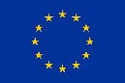
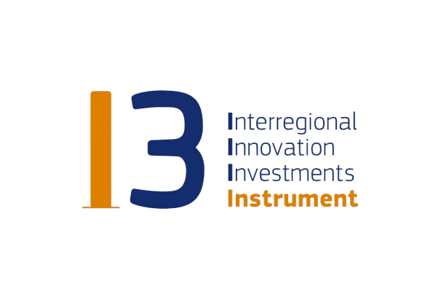
Co-funded by the European Union Under Grant 101161349

CONSORTIUM DECLARATION OF HONOUR

Proposal Title: ______________________________________________________________________________

Proposal Acronym: _________________________________________________________________________

BETWEEN
______________________________________________________________ [SME name] established in ____________________________________________________, [Official address], VAT number ____________________, represented for the purposes of signing and submitting the proposal and the Consortium Declaration of Honour by ___________________________________ [Name of legal representative];

AND

______________________________________________________________ [SME name] established in ____________________________________________________, [Official address], VAT number ____________________, represented for the purposes of signing and submitting the proposal and the Consortium Declaration of Honour by ___________________________________ [Name of legal representative];

AND [remove block below if only two SMEs participate in the consortium]

______________________________________________________________ [SME name] established in ____________________________________________________, [Official address], VAT number ____________________, represented for the purposes of signing and submitting the proposal and the Consortium Declaration of Honour by ___________________________________ [Name of legal representative];

It is hereby agreed that:
All information provided is true and legally binding.
Partner ___________________________________________________ [Consortium leader name] is acting on behalf the following partner(s) as the consortium leader:
Partner 2: __________________________________________ [SME name]
[remove or adjust the following rows below (Partner 3, Partner X, etc.) according to the actual number of entities participating in the consortium and delete this text,]
Partner 3: __________________________________________ [SME name]
The consortium entities have agreed on their roles and budget shares.
The AquaLoops4Med consortium bears no responsibility in case a partner of this project consortium violates the mutual agreement set in this Consortium Declaration of Honour.
The AquaLoops4Med consortium bears no responsibility in the case of dispute among consortium partners regarding intellectual property rights.
By signing this Consortium Declaration of Honour, all consortium partners declare that they – individually or as a consortium – may have only one (1) proposal evaluated under this open call. Any entity, applying solely or as part of a consortium, may only be funded for one project in AquaLoops4Med Open call.
By signing this Consortium Declaration of Honour, all consortium partners declare that they are not members of any other competitive consortium in the AquaLoops4Med open call. In case, an applicant participates in more than one consortium, both consortia will be excluded.
By signing and submitting this Consortium Declaration of Honour, the consortium partners accept all the rules explained in the AquaLoops4Med Open Call Text.
- All partners declare not being in one of the following situations:
  - they are bankrupt or being wound up, have their affairs administered by the courts, have entered into an arrangement with creditors, have suspended business activities, are the subject of proceedings concerning those matters, or are in any analogous situation arising from a similar procedure provided for in national legislation or regulations;
  - they or persons having powers of representation, decision making or control over them have been convicted of an offence concerning their professional conduct by a judgment which has the force of res judicata;
  - they has been guilty of grave professional misconduct proven by any means which the contracting authority can justify including by decisions of the European Investment Bank and international organizations;
  - they are not in compliance with its obligations relating to the payment of social security contributions or the payment of taxes in accordance with the legal provisions of the country in which they are established or with those of the country of the contracting authority or those of the country where the contract is to be performed;
  - they or persons having powers of representation, decision making or control over them have been the subject of a judgment which has the force of res judicata for fraud, corruption, involvement in a criminal organization or any other illegal activity, where such illegal activity is detrimental to the EU financial interests;
  - they are subject to an administrative penalty for being guilty of misrepresenting the information required by the contracting authority as a condition of participation in a grant award procedure or another procurement procedure or failing to supply this information or having been declared to be in serious breach of its obligations under contracts or grants covered by the EU budget.
- Each partner declares that:
  - is not subject to a conflict of interest;
  - has not made false declarations in supplying the information required as a condition of participation in the AquaLoop4Med open call or does not fail to supply this information;
  - is not in one of the situations of exclusion, referred to in the abovementioned points a) to f).
  - Is aware and fully accepts all AquaLoops4Med conditions and rules as expressed in the Open Call text.
- Each partner certifies that:
  - is committed to participate in the abovementioned project;
  - has stable and sufficient sources of funding to maintain its activity throughout its participation in the above-mentioned project and to provide any counterpart funding necessary;
  - has or will have the necessary resources as and when needed to carry out its involvement in the above-mentioned project.

Consortium leader
SME name
Full address
Country
Name of legal representative
Position/ Role
Project budget share | ________________ EUR
I have the power of legally binding the abovementioned SME on submitting this proposal
Legal representative signature and stamp
(stamp if applicable)
Done at (place)___________________________

The (day)_________ (month)_____________(year)___________

Consortium partner no. 2
SME name
Full address
Country
Name of legal representative
Position/ Role
Project budget share | ________________ EUR
I have the power of legally binding the abovementioned SME on submitting this proposal
Legal representative signature and stamp
(stamp if applicable)
Done at (place)___________________________

The (day)_________ (month)_____________(year)___________

Consortium partner no. 3 (delete if not necessary)
Company/organisation name
Full address
Country
Name of legal representative
Position/ Role
Project budget share | ________________ EUR
I have the power of legally binding the abovementioned SME on submitting this proposal
Legal representative signature and stamp
(stamp if applicable)
Done at (place)___________________________

The (day)_________ (month)_____________(year)___________

